This article was contributed by Mike Wild.

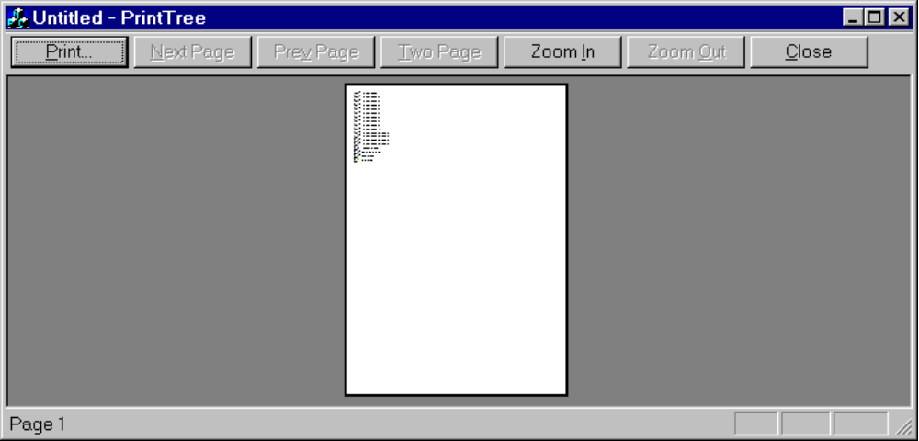

As I realized a lot of developer are interrested in code for printing CTreectrl. I was in the same situation and tried a lot of different ways, but every approach had its disadvantage.

The simples solution seemed the call of CWnd::print(...), but this only prints the visible part of the control, which was not what I wanted. One advise for this approach was the scroll the TreeCtrl in the printing code from the start to the end and call after every scroll CWnd::print(...), which was a little bit weired for me. Additionally I wanted as much flexibility in my code as possible, which means printing with or without icons, lines, buttons.

That’s why I began to implement the whole stuff by myself, following the next few steps:

Init ImageList:
In my opinion and my understanding of OOD the Treecontrol should be able to display itself, that’s why it should have the imagelist and initialize it;

Paging:
This is also done by hand, like everything else. Iterating through the tree and create an array with the PagingInfos:

struct PagingInfos
{
HTREEITEM m_hStartItem;
int m_iNumberOfItems;
};

DrawTreeCtrl:
Iterating through the tree and print every node by myself including lines and buttons.

Imagelist vs DIB:
In an additional step I wanted to print the tree in color. This was easy for text, but not for the icons. I tried a lot to convert the imagelist to DIB, but what I really needed was a method, which gives back the DIB of one icon, not of the whole Imagelist.

Bugs and Improvements:
- Compiling the releaseversion is now working too.
- If the convertion to DIB failes the program gives back an errorcode and prints without grafic( see Comment below).

Comment:
After the first release I received some Mails about problems with the example project, which was crashing under some conditions. My problem is, that everytime I tested my code under the described conditions it worked fine. What I’ve done now, was to extend the project with more errorhandling and it would be nice, if all users which are receiving errorcodes, could report me the following informations:
- Errorcode
- OS with servicepack
- IDE with servicepack
- Optional: Which convertion failed

Please report all bugs and improvements to me, thanks and enjoy it.

